JOBSHEET 8

MS PowerPoint

Team teaching

Politeknik Negeri Malang

JOBSHEET 8

MS PowerPoint 2010 - 2016

1. Job Instructions
2. Working on case studies, trainings and assignments on the worksheet properly and correctly.
3. Not allowed to cheat tasks with other students. If the cheating occurred, the lecturer will impose a penalty to students who asked and gave the answer then both student scores will be down to 0.
4. All answers of case studies, exercises and assignments are done in the available columns, and all of you are obliged to write down the work steps.
5. Work is collected with the format NAME-STUDENT ID-T8-CLASS in the folder.
6. After the student finished the case studies, training and assignments, the work has to be  
   submitted to the lecturer to do the assessment.
7. Students can ask questions if the work descriptions are poorly understood.
8. Worksheet
9. Do the following questions:
   * Open powerpoint2016_videos_practice.pptx. Also, butterfly.mp4
   * On slide 2, **Insert** our example video file.
   * **Resize** the video so it fits next to the text box.
   * Apply a **video style** of your choice.
   * **Trim** the video so the start time is around 00:17.5 and the end time is around 00:25.
   * Add a **bookmark** somewhere in the middle of your video.
   * When you're finished, **preview** your video. It should look something like this:

[](1.%20Inserting%20Videos/butterfly.mp4)

* + Save by name T8.1_videos_NAME.pptx

1. Do the following questions:
   * Open powerpoint2016_audio_practice.pptx. Also, minden_something_small.mp3
   * On slide 3, **insert** our example audio file.
   * **Move** the file to the bottom-left corner of the slide.
   * **Trim** the audio so the start time is around **00:15** and the end time is around **00:55**.
   * Change the **Fade Duration** to **02:00** for fade in and **08:00** for fade out.
   * Set the audio to **Start Automatically** and **Play Across Slides**.
   * **Change the icon** to an online picture of your choice.
   * When you're finished, your slide should look something like this:

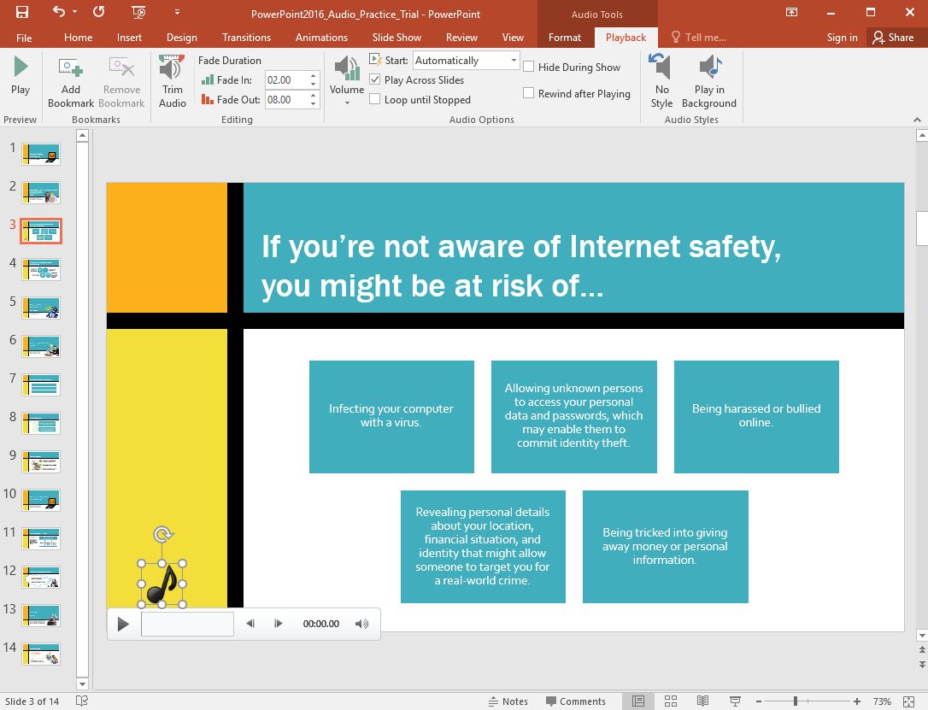

* + Save by name T8.2_audio _NAME.pptx

1. Do the following questions:
   * Open powerpoint2016_tables_practice.pptx
   * On the last slide, **insert a table** with 5 columns and 3 rows.
   * In the first row, type the name of the months January through May. In the second and third rows, type sale amounts of your choice (for example, $1329).
   * Change the **style** of the table.
   * **Insert** a column on the left side of the table.
   * On the **second row** of the new column, type **North Region**. On the **third row**, type **South Region**.
   * **Delete** the last column.
   * **Resize** your table so it takes up the majority of the slide.
   * **Center** your text horizontally and vertically.
   * When you're finished, your slide should look something like this (table style and colors may vary):

[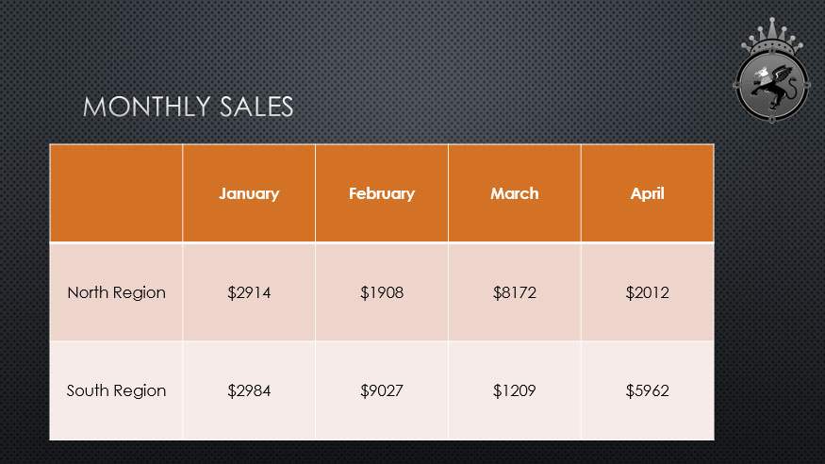](4.%20Applying%20Transitions/transitiongif.gif)

* + Save by name T8.3_tables_NAME.pptx

1. Do the following questions:
   * Open powerpoint2016_charts_practice.pptx
   * On the last slide, insert a **line** chart.
   * Open our **practice workbook** in Excel. Copy the data and paste it into the chart's spreadsheet.
   * **Delete** the **chart title**.
   * Change the **chart type** to **Stacked Column**.
   * Use the **Quick Layout** drop-down menu to change to **Layout 10**.
   * Click the **Chart Elements** shortcut button, click the arrow next to **Axis Titles**, and select the **Primary Vertical** axis title.
   * Double-click the axis title, then rename it **Sale Profits**.
   * **Switch** the **Row/Column** data.
   * When you're finished, your slide should look something like this:

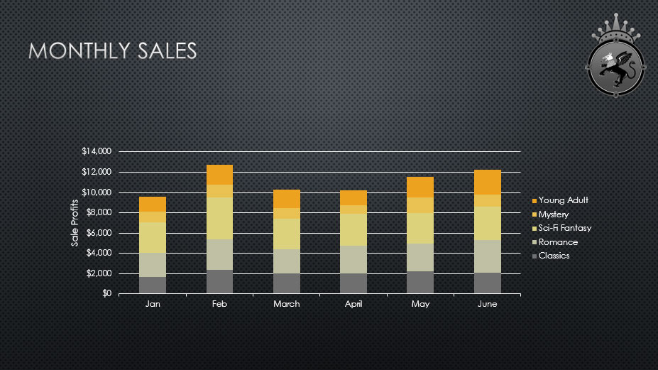

* + Save by name T8.4_charts_NAME.pptx

1. Do the following questions:
   * Open a **blank presentation** and insert a new slide with a **Title and Content** layout.
   * In the **Title** placeholder, type **The Water Cycle**.
   * In the **Content** placeholder, choose the **SmartArt** command and insert a **Basic Cycle SmartArt** graphic from the **Cycle** category.
   * Insert the following text in clockwise order: **Condensation**, **Evaporation**, **Infiltration**, **Precipitation**, **Collection**.
   * **Delete** the shape containing the word **Infiltration**.
   * Select the shape containing **Evaporation**, and click the **Move Down** command **twice** to move the shape between **Collection** and **Condensation**.
   * Change the **SmartArt Layout** to **Block Cycle**.
   * Change the **colors** of the SmartArt to a range of your choice.
   * Change the SmartArt Style to **Intense Effect**. The style names will appear when you hover over them.
   * When you're finished, your slide should look something like this:

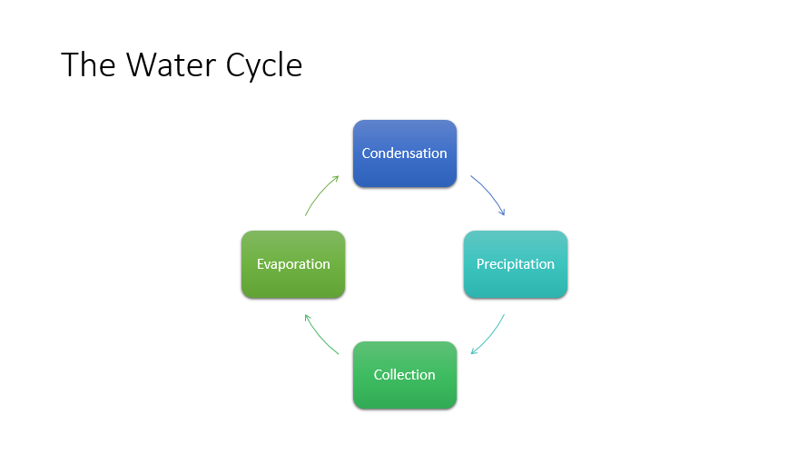

* Save by name T8.5_smartart_NAME.pptx

1. Do the following questions:

* Open powerpoint2016_modifyingthemes_practice.pptx
* Change the **theme colors**.
* Use the **Customize Fonts** command to change the theme's heading font to **Garamond** and the body font to **Arial**.
* Change the theme's **background style**.
* **Optional:** Save your customized theme.
* When you're finished, your first slide should look something like this (your colors and background style may vary):



* Save by name T8.6_modifyingthemes_NAME.pptx

**-HAVE A GREAT TIME DOING IT-**